Name : B. Nandini Course : Software Engineering
Reg No : 192525137
Experiment – 2

Question : Sketch a Simple Prototype of a Bus Ticket Booking System using
Figma Tool.

Step 1: Open Figma
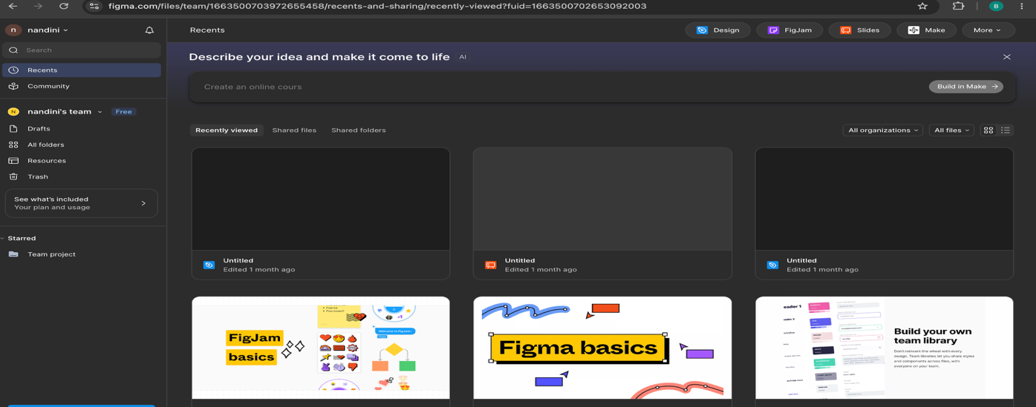
Step 2: Create the Project
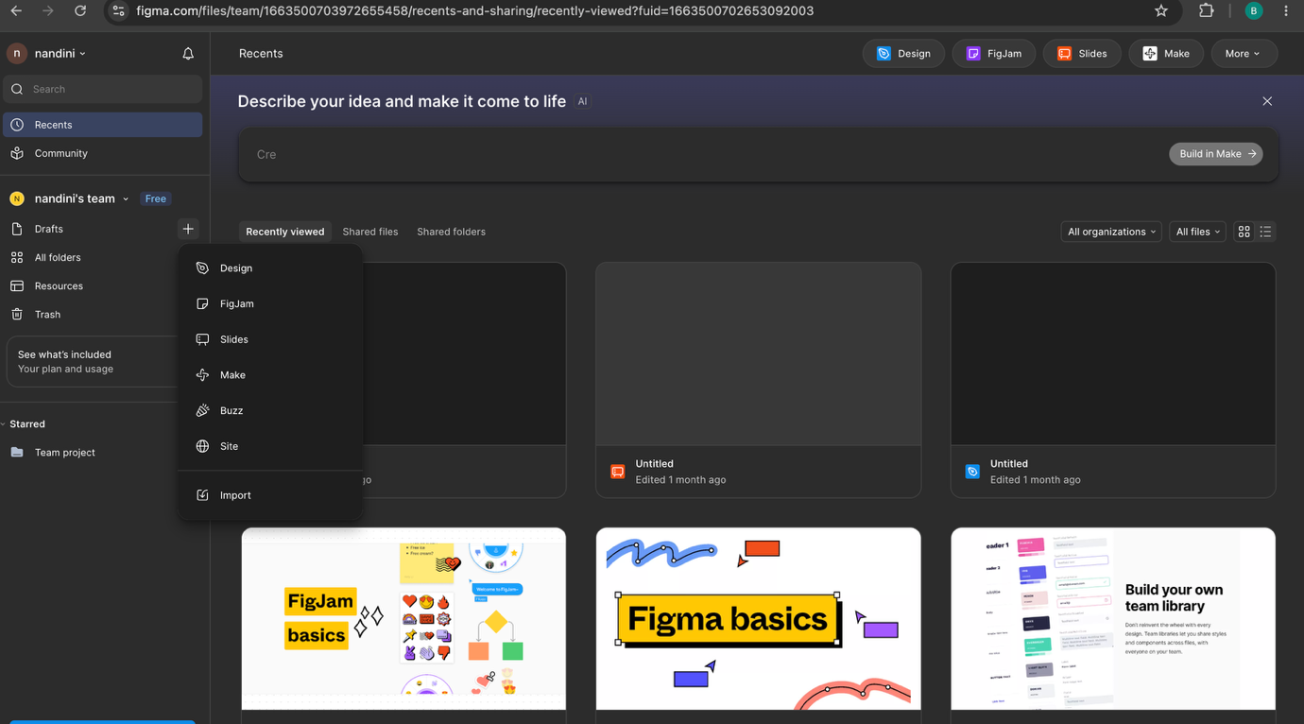
Step 3: Design the Home/Login Page
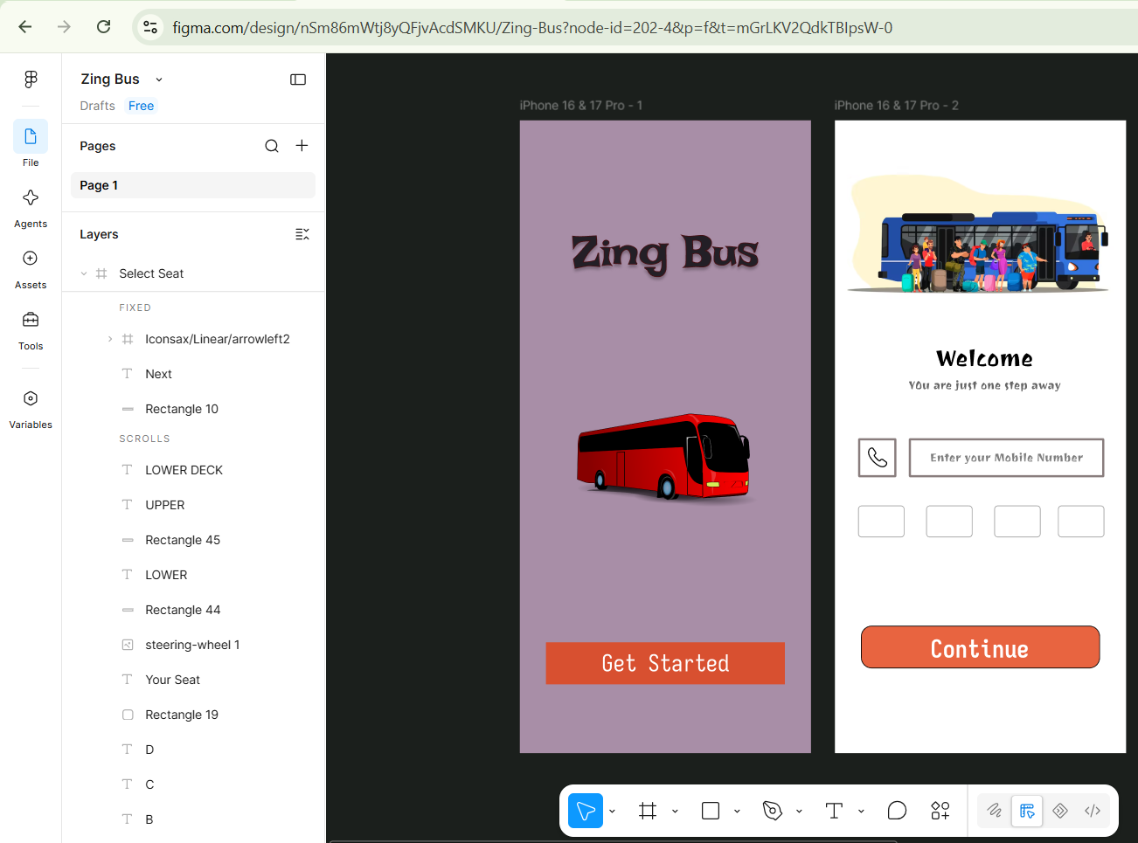

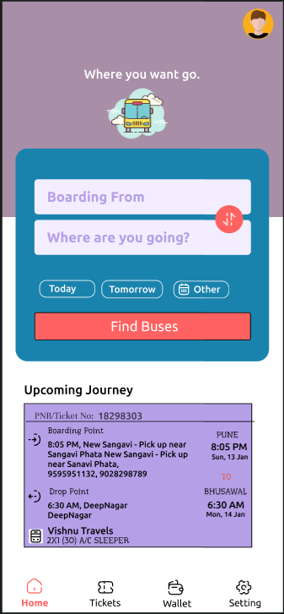
Step 4: Design the Bus Search Page

Step 5: Design the Bus Selection Page
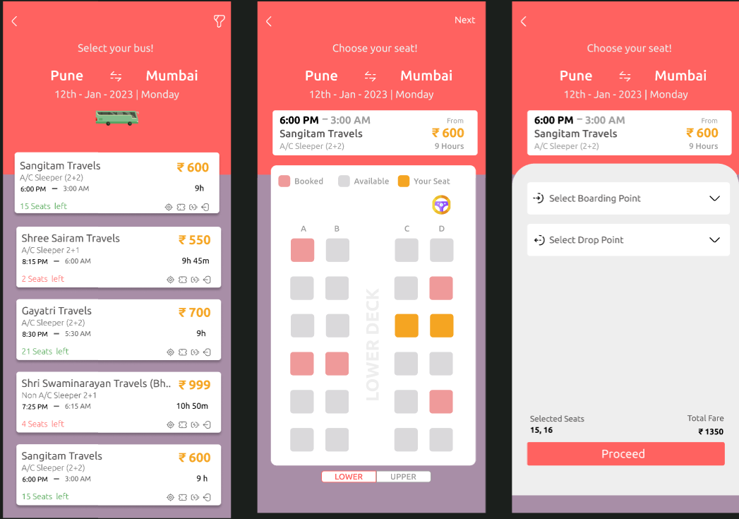

Step 6: Design the Seat Selection Page


Step 7: Design the Booking Confirmation Page


Step 8: Connect the Screens
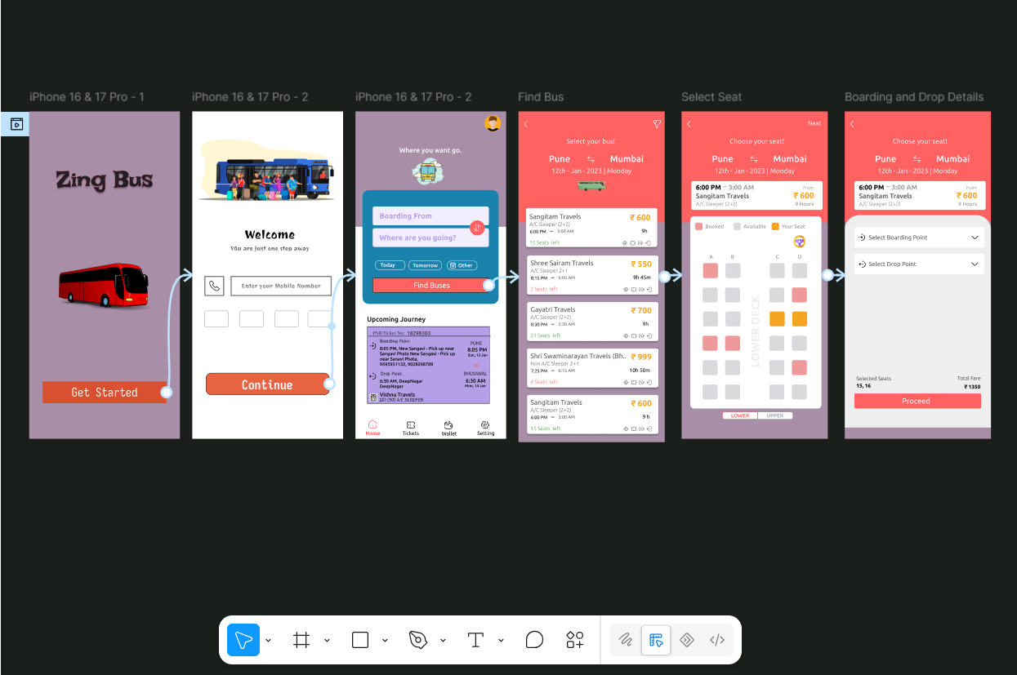

Step 9: Test the Prototype

